**Scheduled Refresh:**

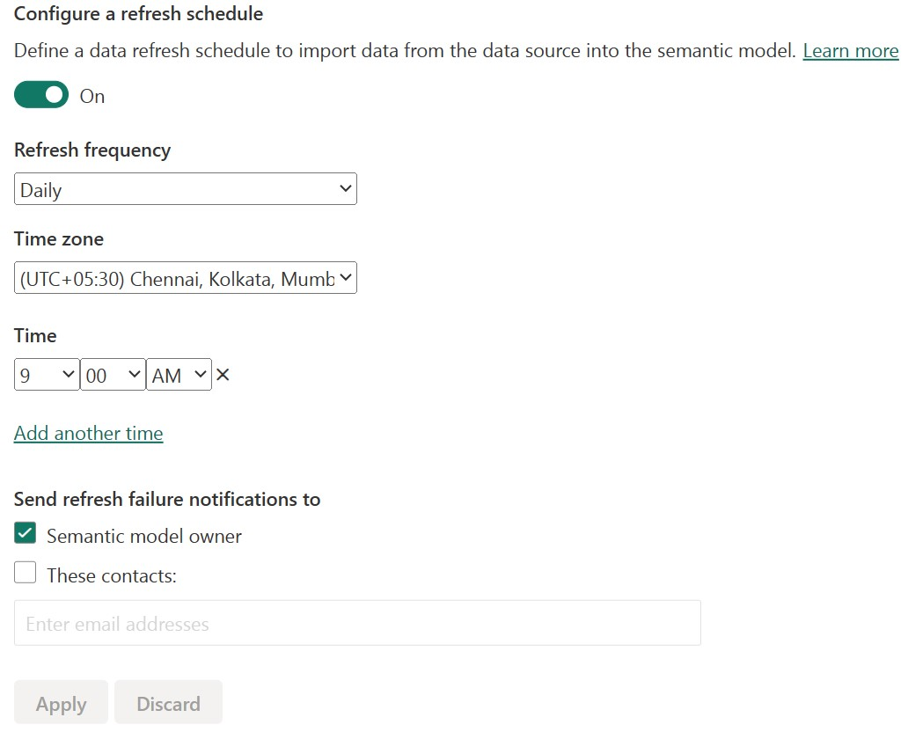

**Next Refresh Time:**

